ASSIGNMENT:  
**Windows Server Backup and Windows Server**

Assignment Description:  
 *"You are a system administrator in a company that is on the Server user _ime-SRV01, in the C:/Data folder, has financial data that needs to be backed up regularly. Use Windows Server Backup to make regular backups of all data on the server. You need to install Windows Server Backup on the server korisničko_ime-SRV01 and configure it according to the following requirements:*

* *Backup/backup configuration: Full server (recommended);*
* *Backup start time: once a day 03:00;*
* *Backup destination type: Backup to a shared network folder;*
* *Remote folder://korisničko_ime-SRV03/BackupData;*
* *Username/username to configure the backup:Administrator*
* *Password: The password you use for your administrator account.*

*Run Windows Server Backup on the SRV-1 server, after which you will run a one-time backup for the C:/Data folder.*

**Course**: Windows Server 2022 OS - Infrastructure  
**Module**: High Availability and Disaster Recovery  
**Student**: Jovan Ljušić  
**03.05.2024**

This document presents a step-by-step approach to solving a specific task, outlining the methodology, execution, and expected outcomes. By following the instructions, the reader will gain hands-on experience in applying technical concepts to practical situations, reinforcing both theoretical knowledge and problem-solving abilities.

The structured approach ensures that each step is clearly defined, making the process easy to follow and implement in professional environments.

At the very beginning of the task, I will start the virtual machine with the name assigned in the task, and after that I will begin the installation of Windows Server Backup features, as shown in the attached images.

*"You are a system administrator in a company that is on the Server user _ime-SRV01, in the C:/Data folder, has financial data that needs to be backed up regularly. Use Windows Server Backup to make regular backups of all data on the server.*

*You need to install Windows Server Backup on the server korisničko_ime-SRV01"*

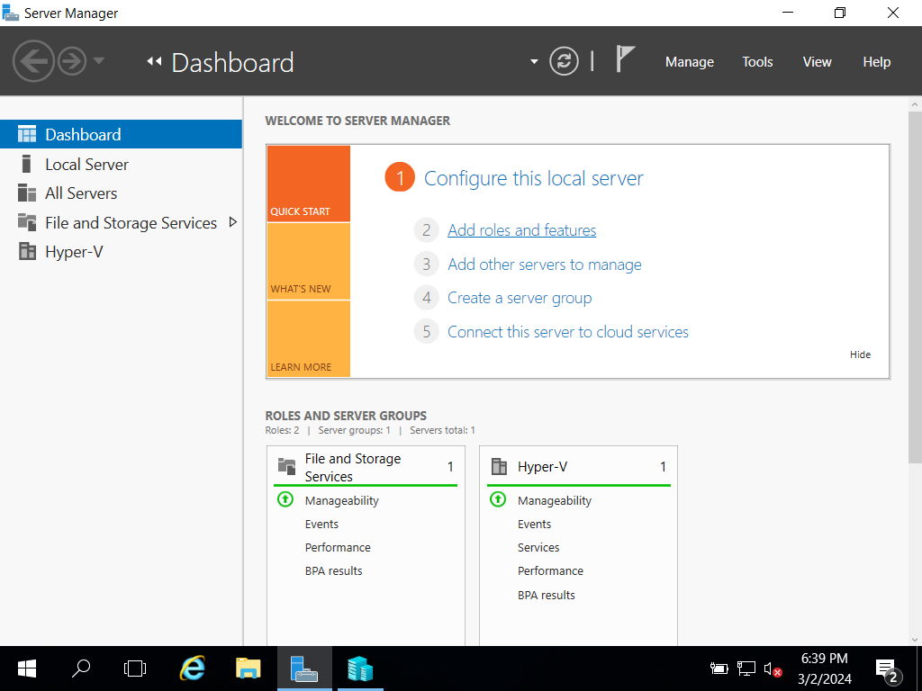

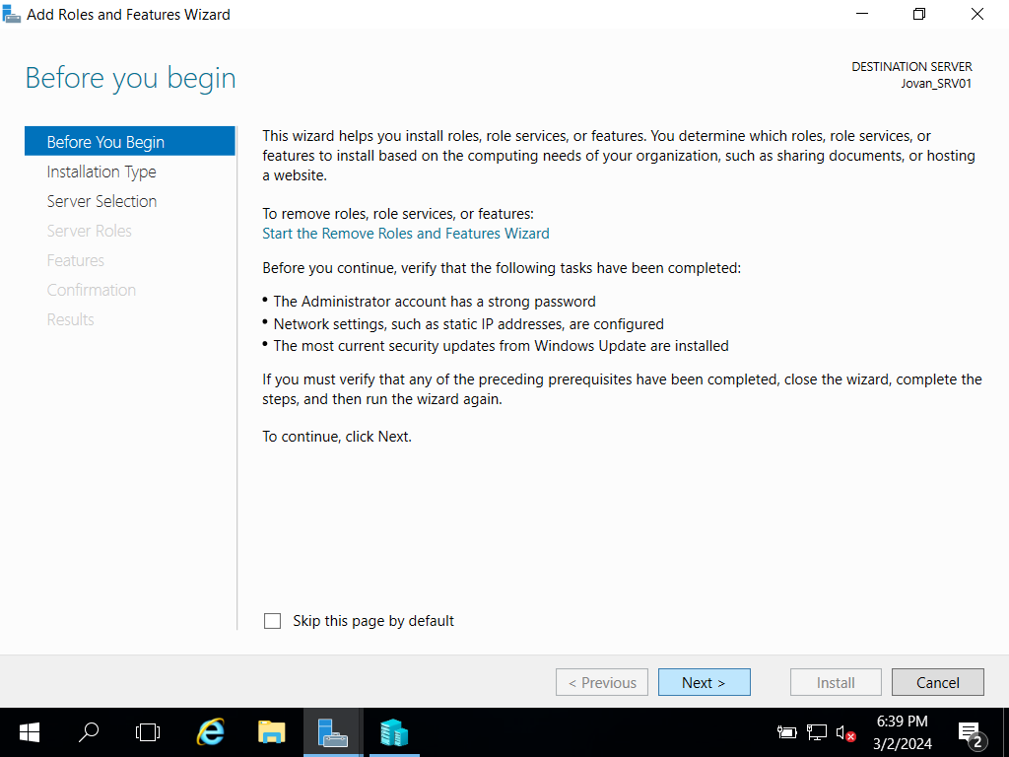

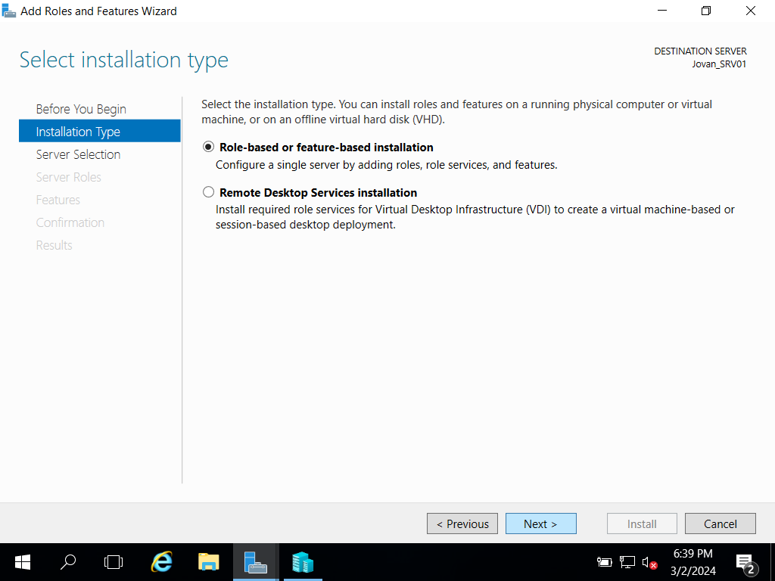

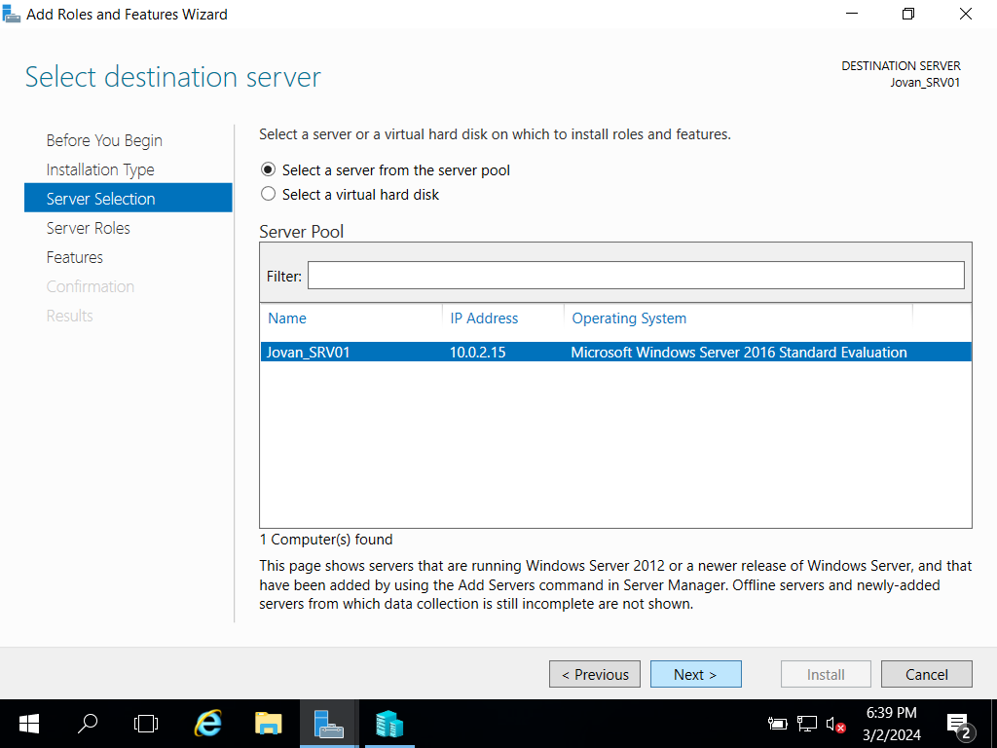

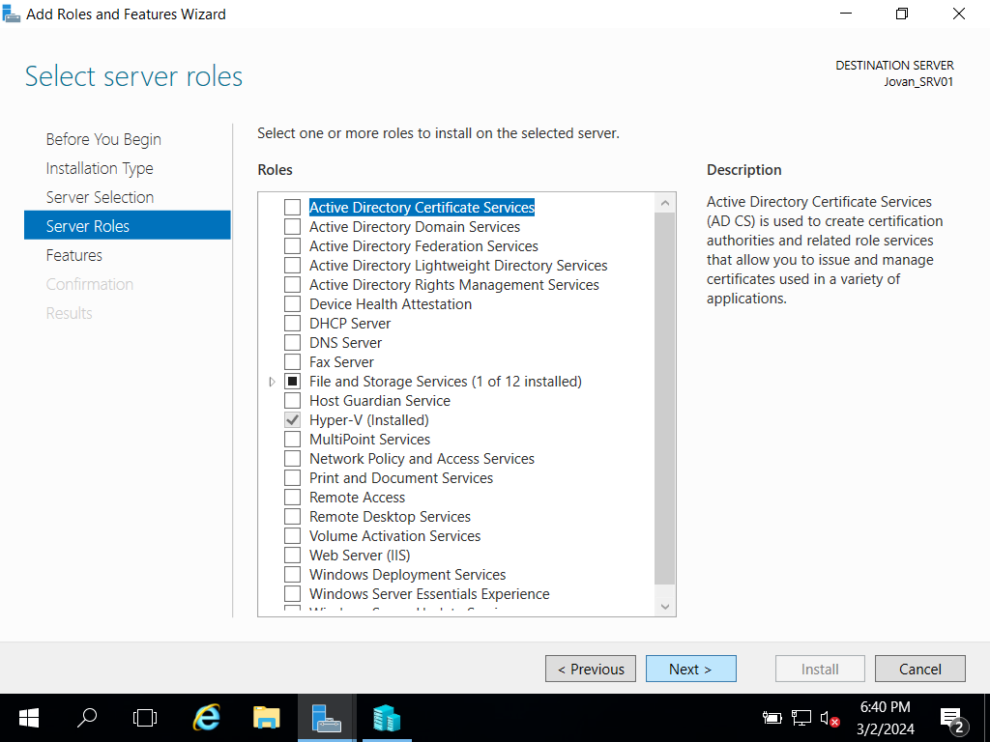

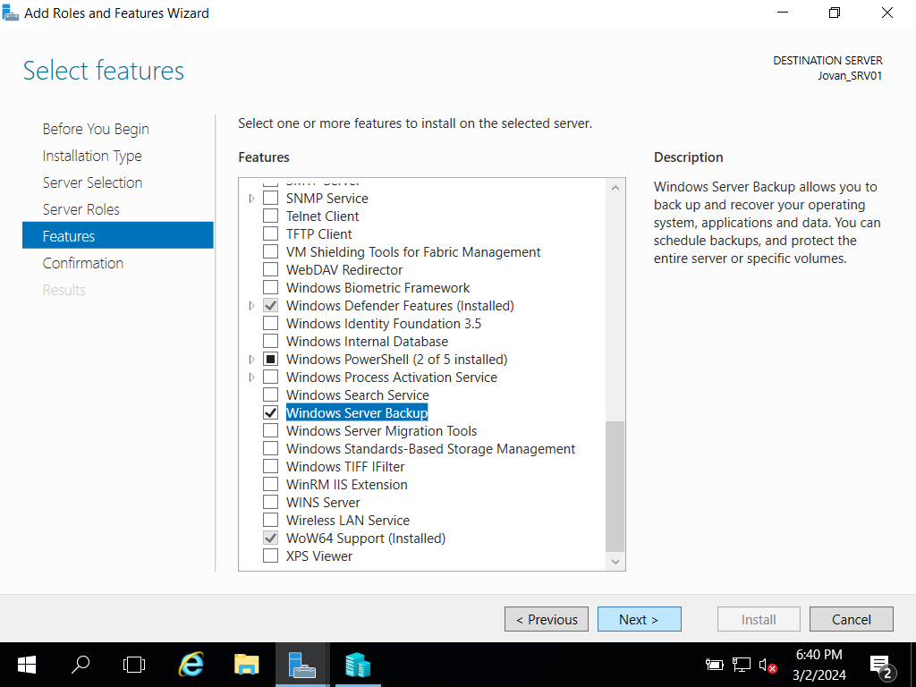

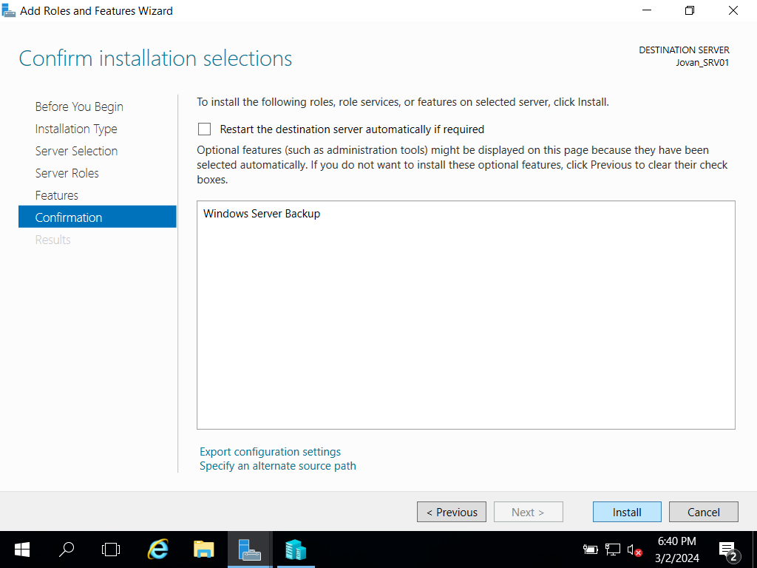

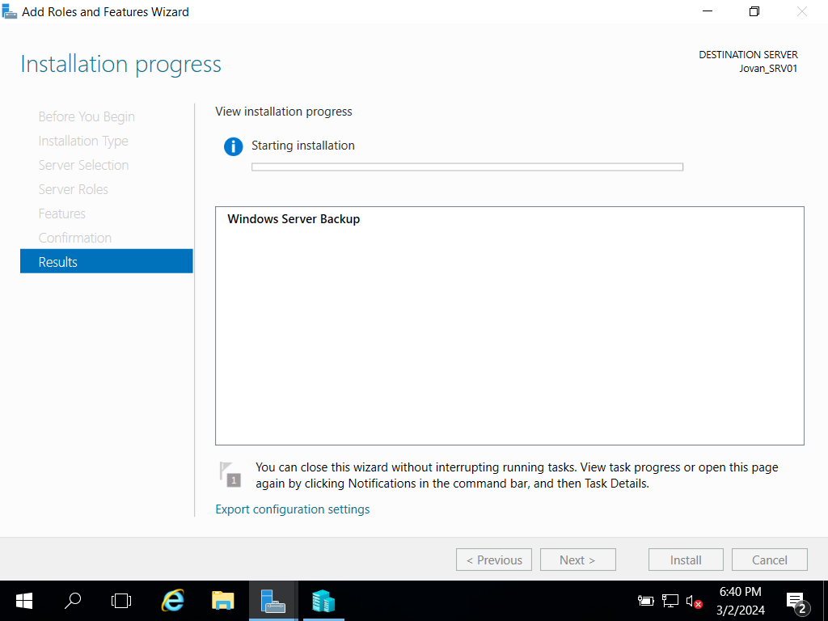

Each image shows a step that follows the process of adding specific options, such as Windows Server Backup. After that, I will create a folder that will contain the purpose of the task and will be named *Remote Folder://korisničko_ime-SRV03/BackupData.*

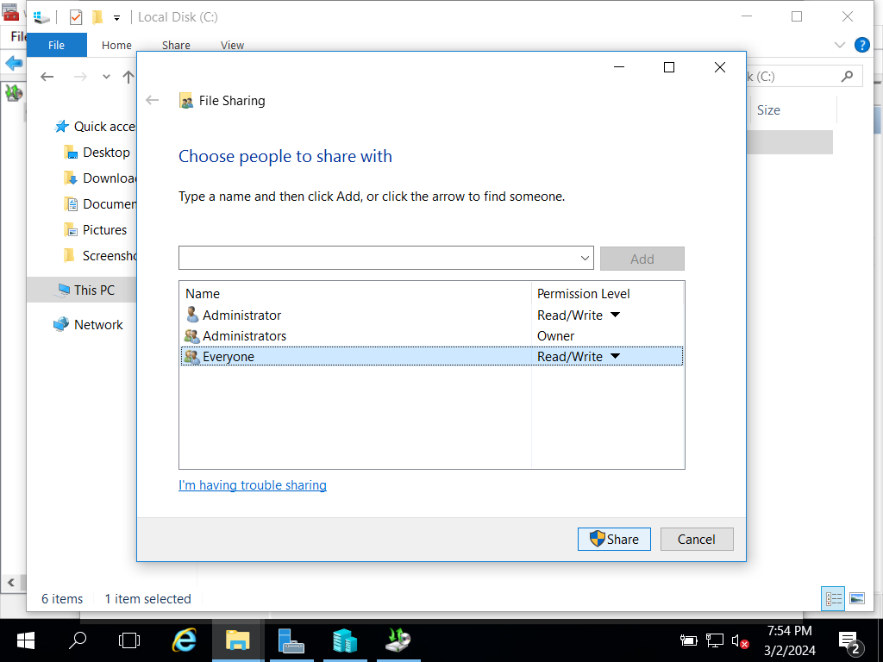

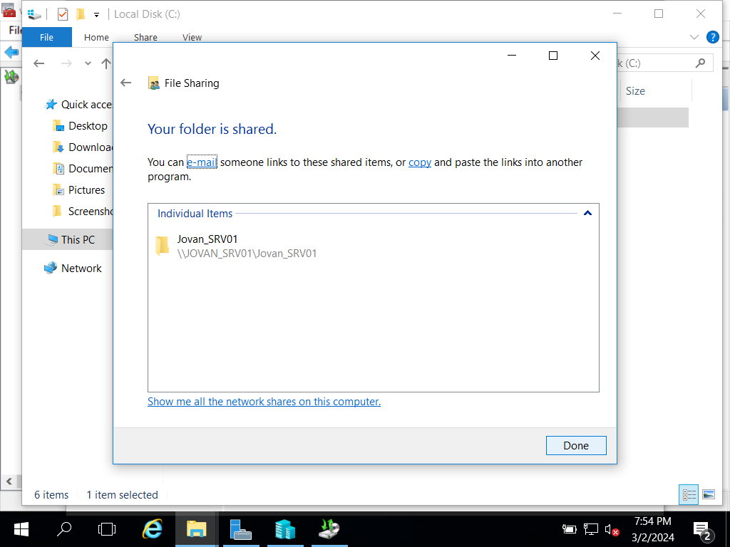

The next part of the task includes setting the backup options, as stated in the task, as well as the process of starting the backup as can be seen in the following images.

*You need to install Windows Server Backup on the server korisničko_ime-SRV01 and configure it according to the following requirements:*

* *Backup/backup configuration: Full server (recommended);*
* *Backup start time: once a day 03:00;*
* *Backup destination type: Backup to a shared network folder;*
* *Remote folder://korisničko_ime-SRV03/BackupData;*
* *Username/username to configure the backup:Administrator*
* *Password: The password you use for your administrator account.*

*Run Windows Server Backup on the SRV-1 server, after which you will run a one-time backup for the C:/Data folder.*

